Section 14: SQS, SNS, Kinesis, ActiveMQ

AWS Solution Architect Associate

# 156. Amazon SQS – Standard Queues Overview

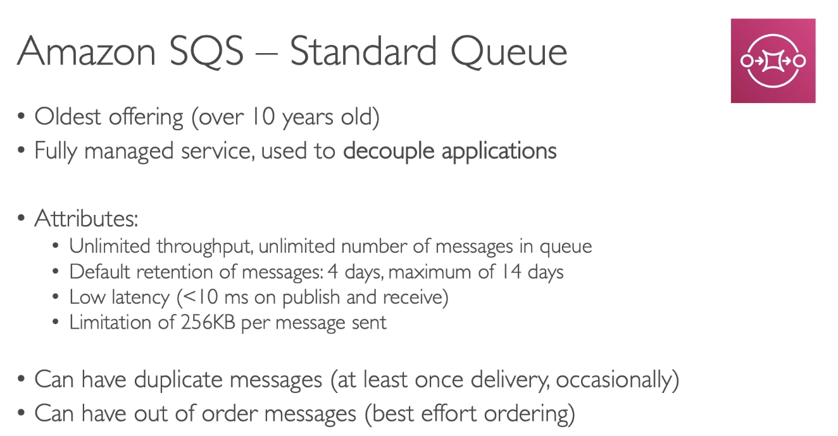

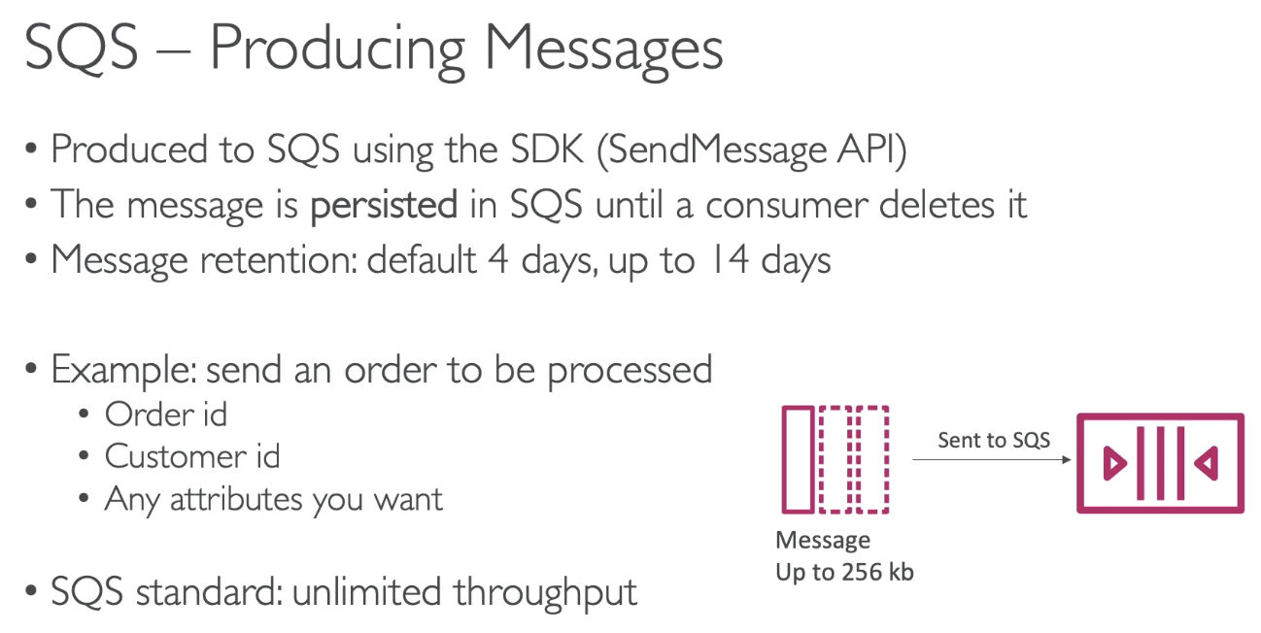

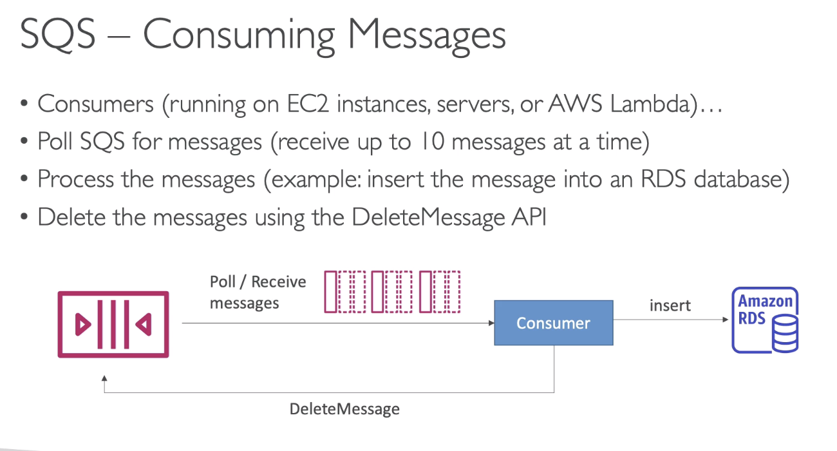

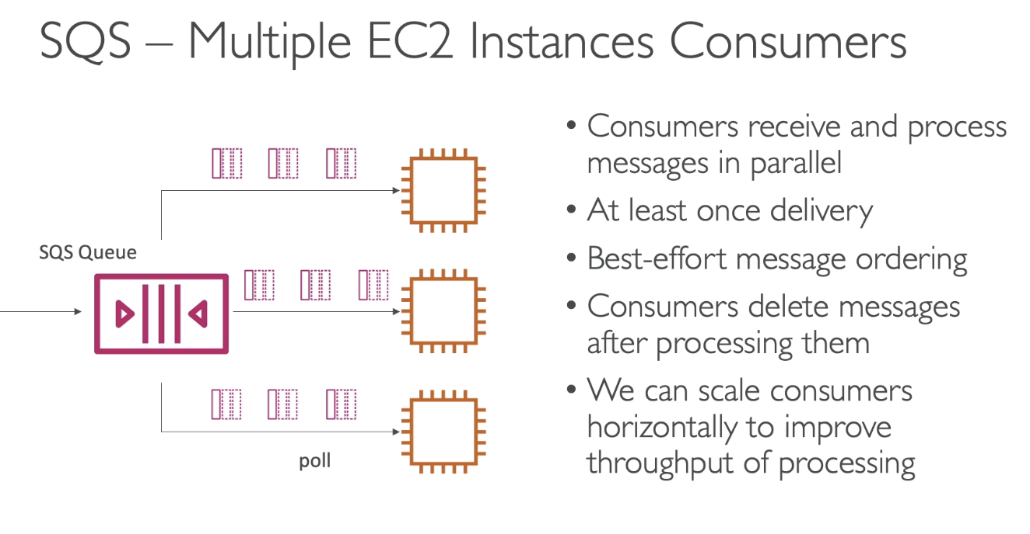

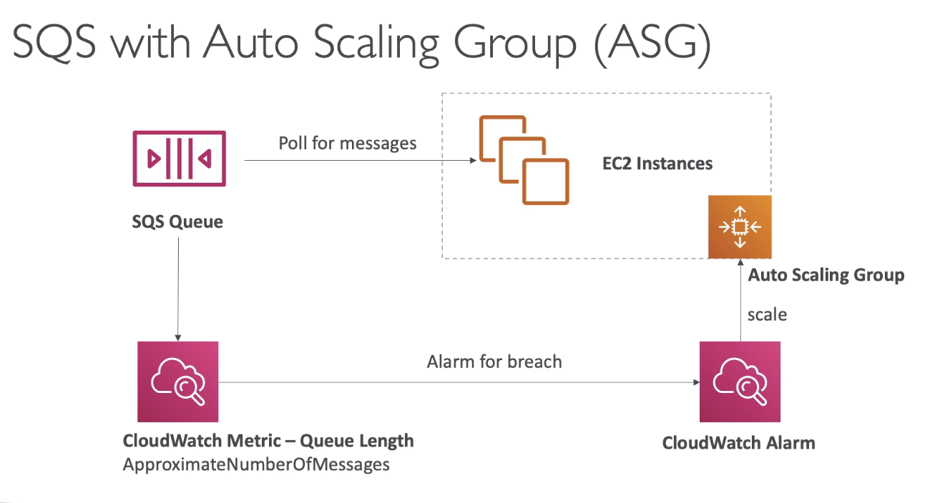

Here the ASG has to be scaling based on some metric. The metric that is available to us is **queue length**. We could set up an alarm such as whenever the queue length go over a certain level then setup the CloudWatch alarm. This alarm should increase the capacity of my ASG by x amount. This will guarantee that when there is more messages in the SQS queue more EC2 instances will be provided and you will automatically process these messages with a higher throughput.

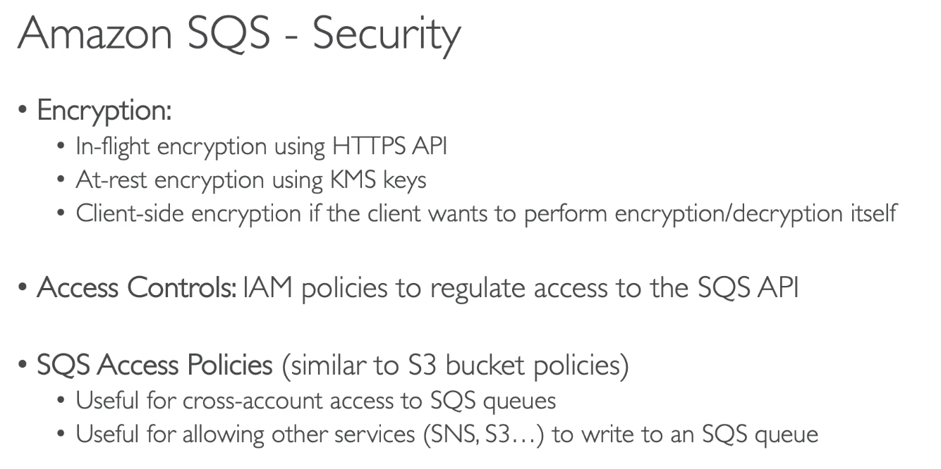

# 178. SQS Queue Access Policy

Use Case:   
- Queue access policy will allow your EC2 instance to poll from SQS queue in another account.

- You have a S3 bucket, that publishes event notification to a SQS queue.

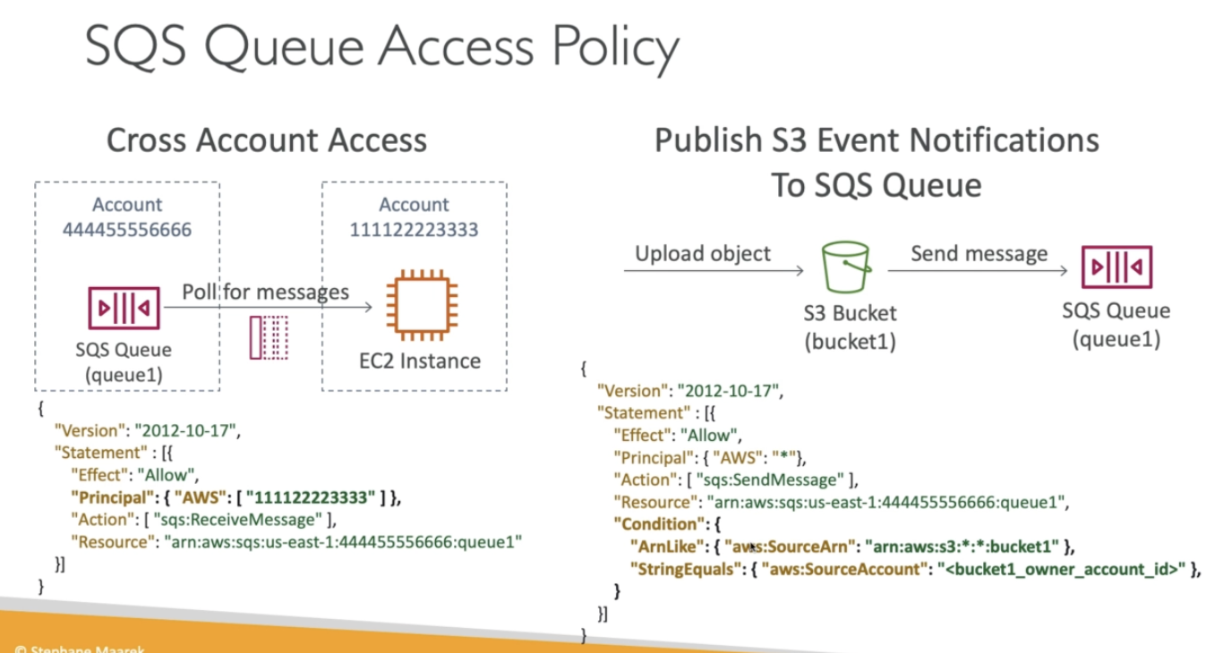

ExamTip:

Qn: What is needed to write to a SQS queue, for cross account access or publishing S3 event notification?

# 158. SQS – Message Visibility Timeout

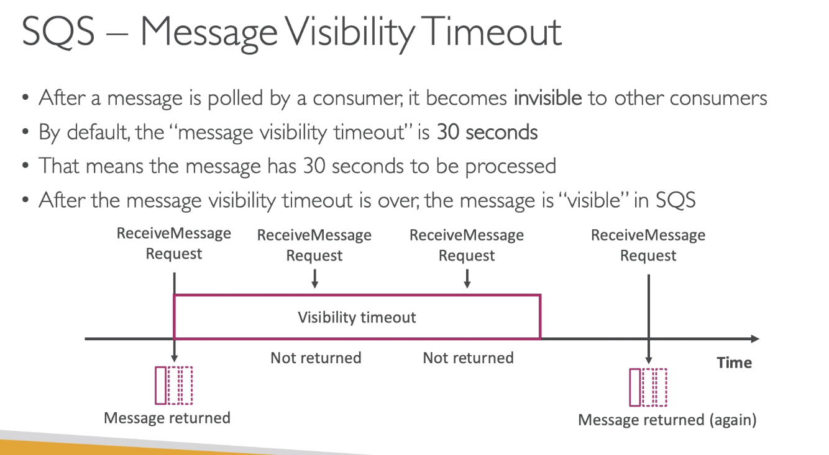

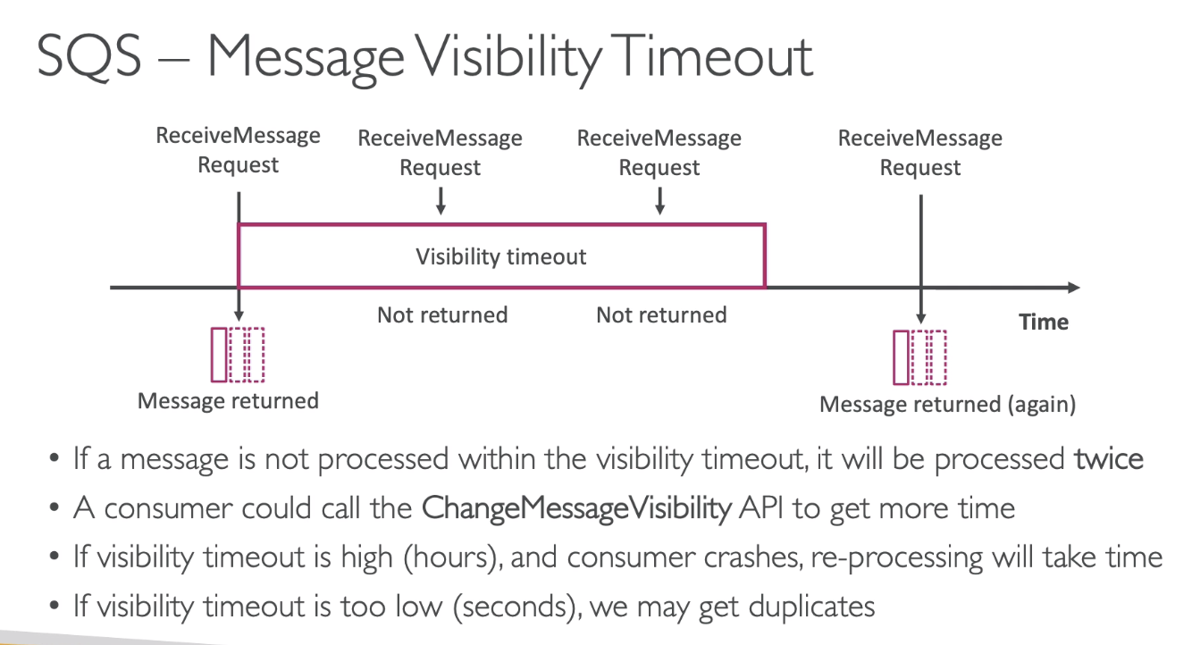

The idea is:

🡪 the visibility timeout should be set to something reasonable for your application,

🡪 your computer should be programmed that if they know they need a bit more time then they should call the ChangeMessageVisibility API

# 159. SQS – Dead Letter Queues

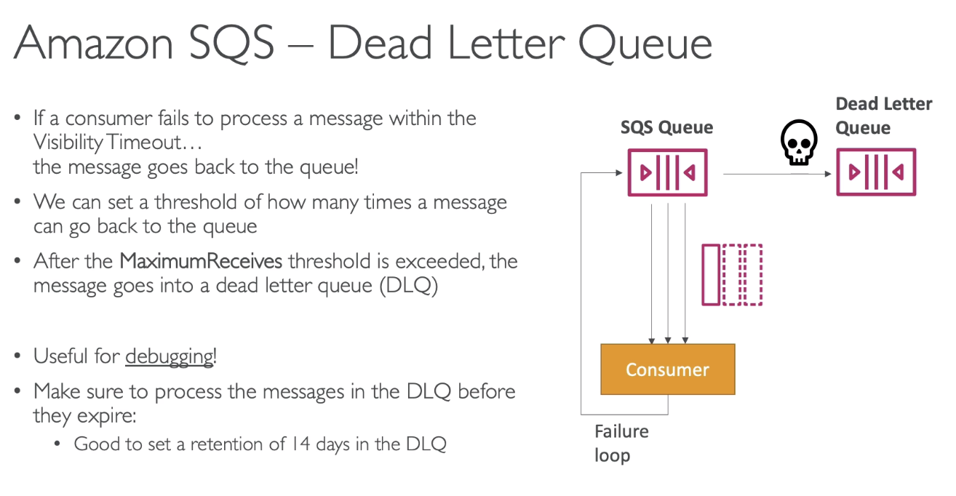

# 181. SQS – Request Response

## Temporary Queue Client

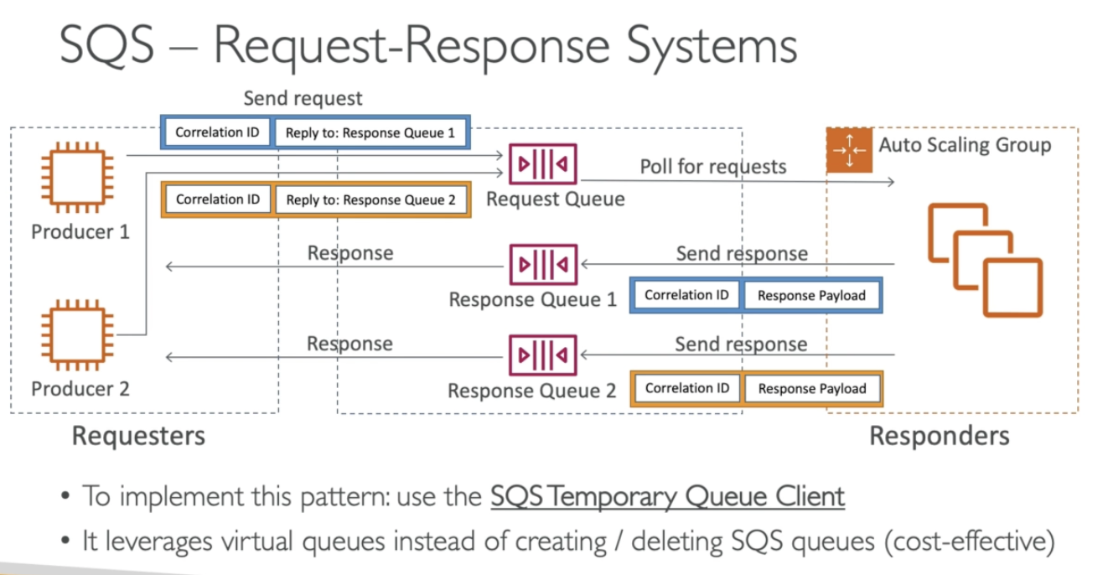

** Remember that:

Exam may ask – how do you implement request-response systems?

Ans: using **SQS Temporary Queue client**. This is directly created by AWS.. if we use this queue, we don’t have to worry about the implementation details of this pattern.

# 160. SQS – Delay Queues

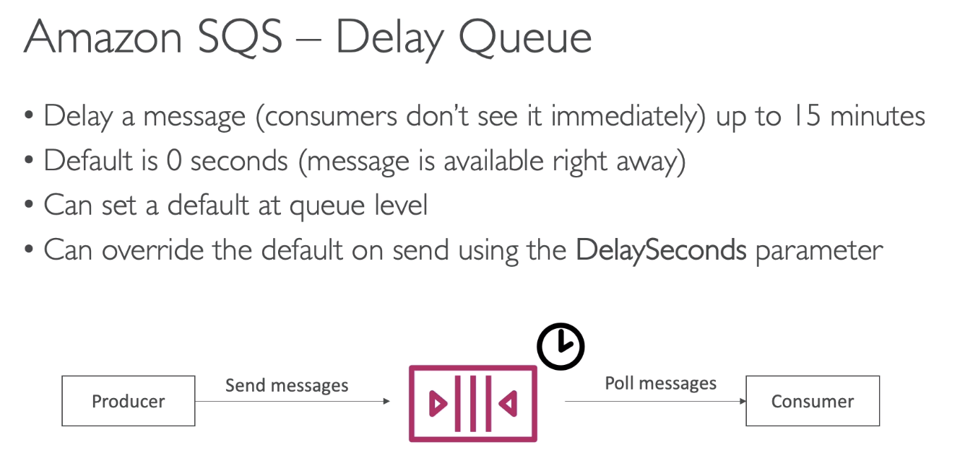

By setting default value at queue level, we set all the messages to be delayed by x amount of time. Or every time you send a message, you can set a per message delay by setting the **DelaySeconds** parameter.

# 161. SQS – FIFO Queues

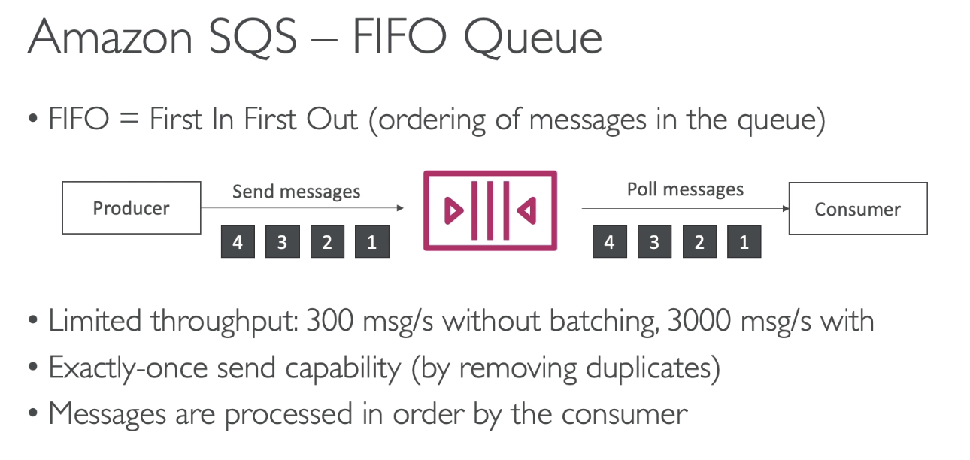

* While creating the queue, the queue name must end with .fifo; example – DemoQueue.fifo; otherwise the queue will not work

# 162. SQS + Auto Scaling Group

# 163. SNS – Overview

PUB-SUB Pattern

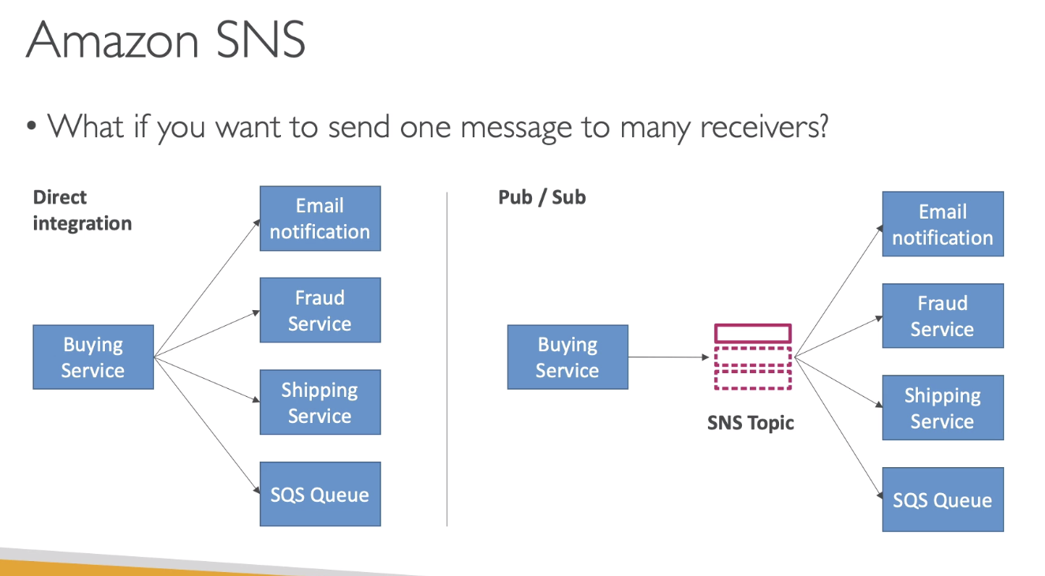

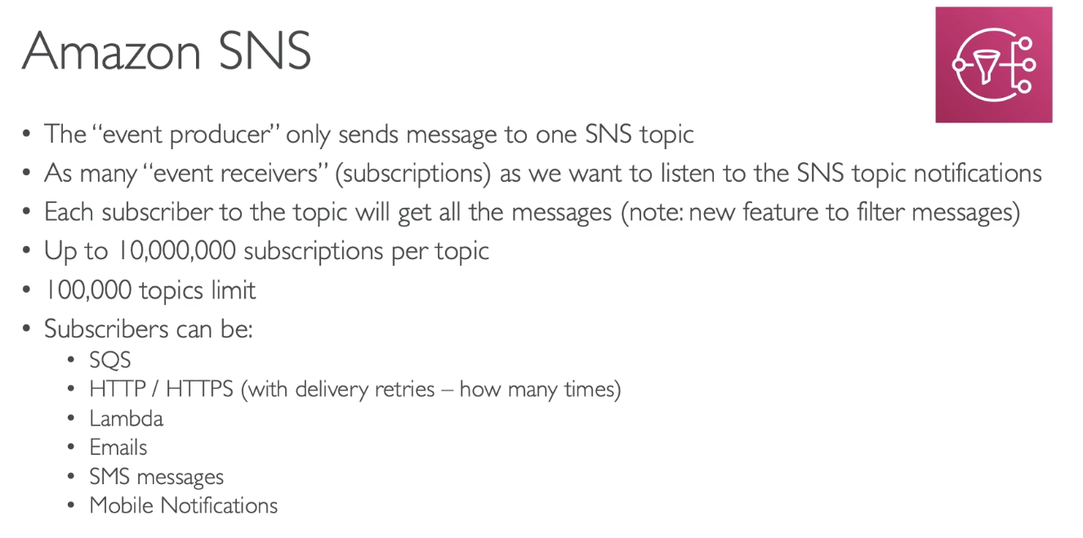

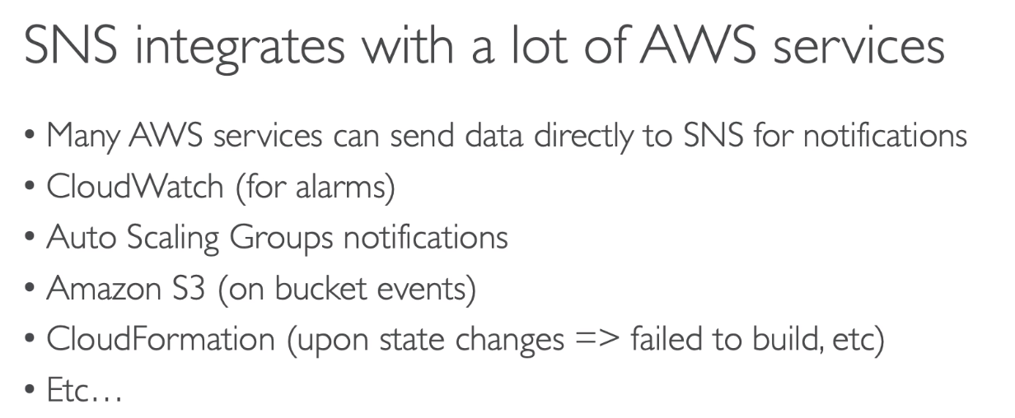

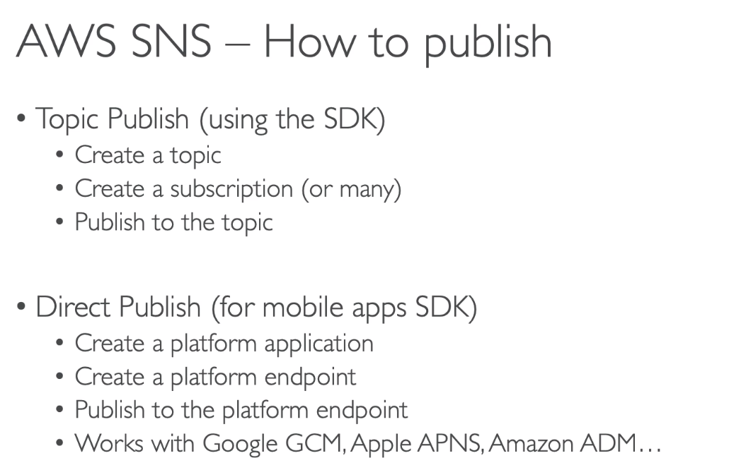

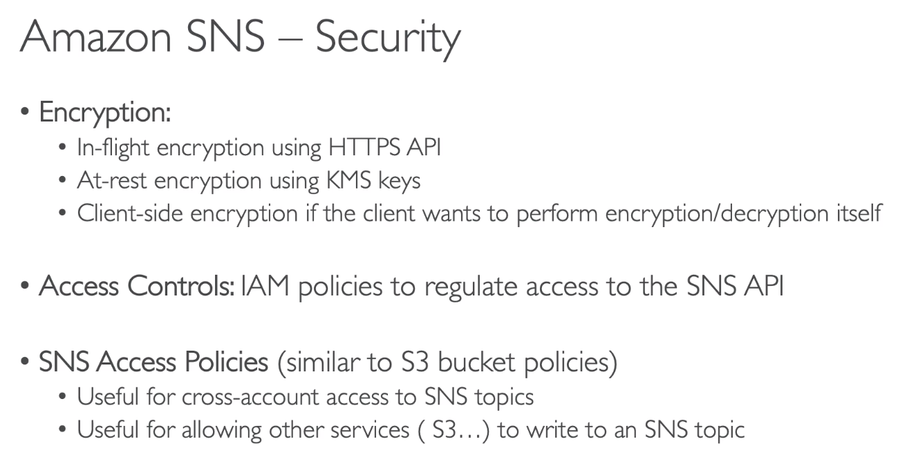

Exam Tip: Remember the protocols for creating subscription for SNS topic. 🡪 HTTP, HTTPS, Email, etc…

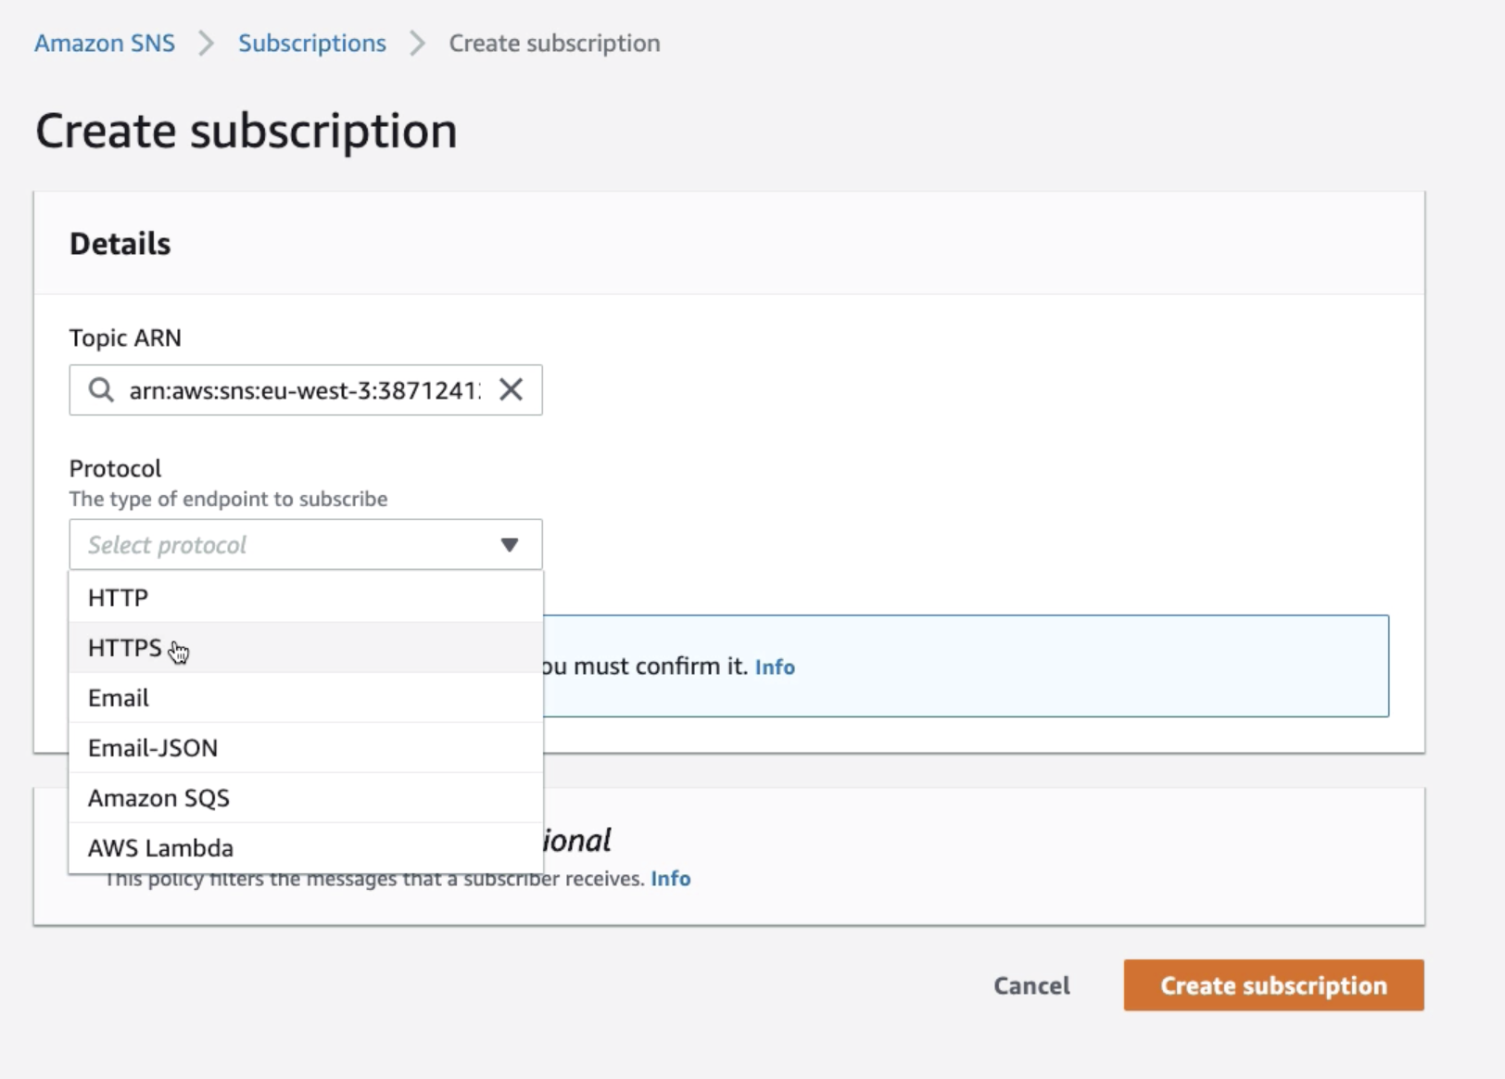

# 165. SNS and SQS – Fan Out Pattern

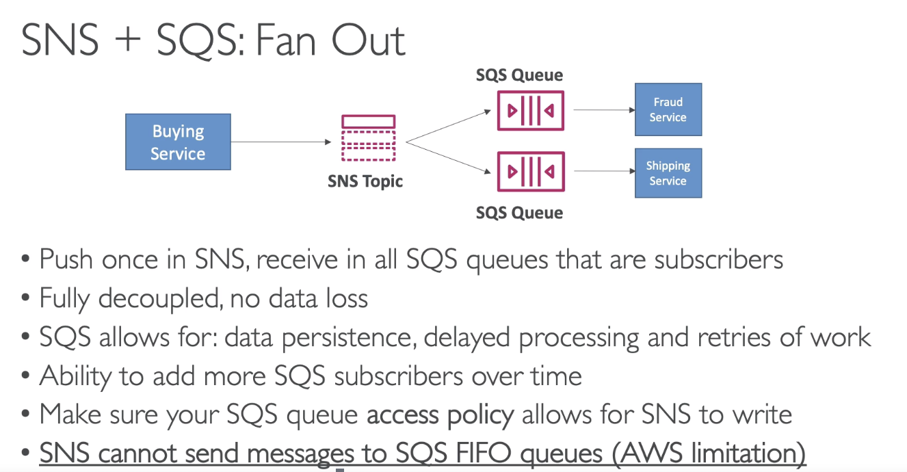

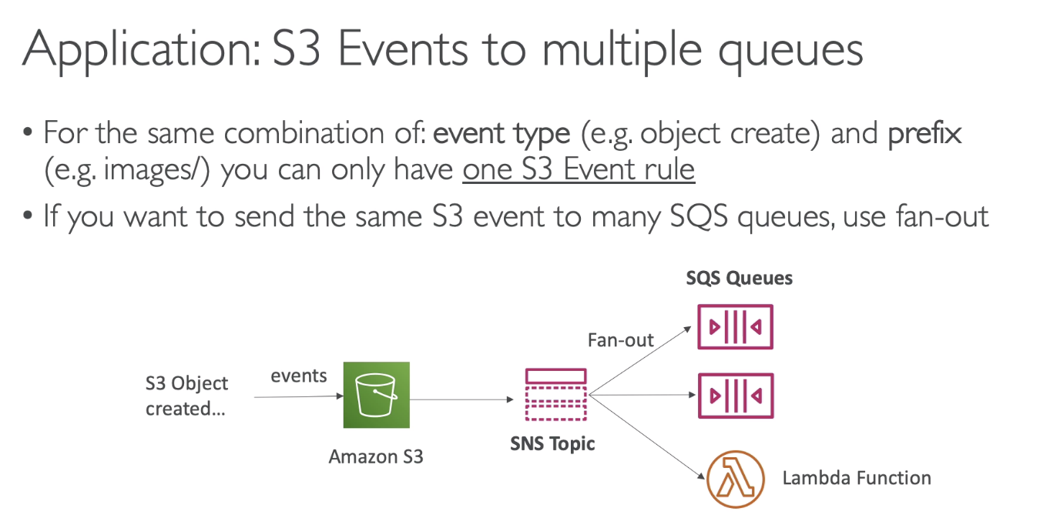

# 166. Kinesis Data Streams Overview

## Overview

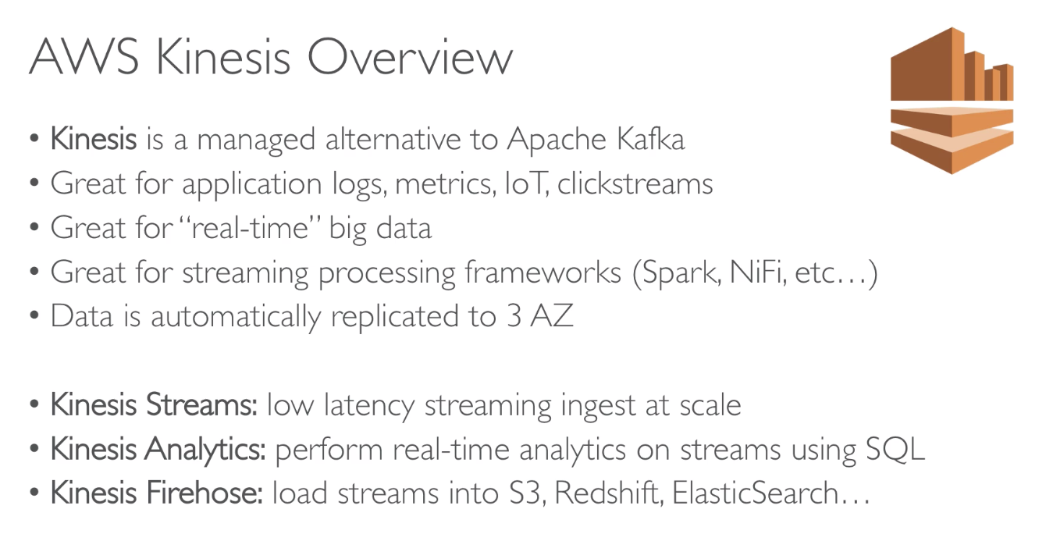

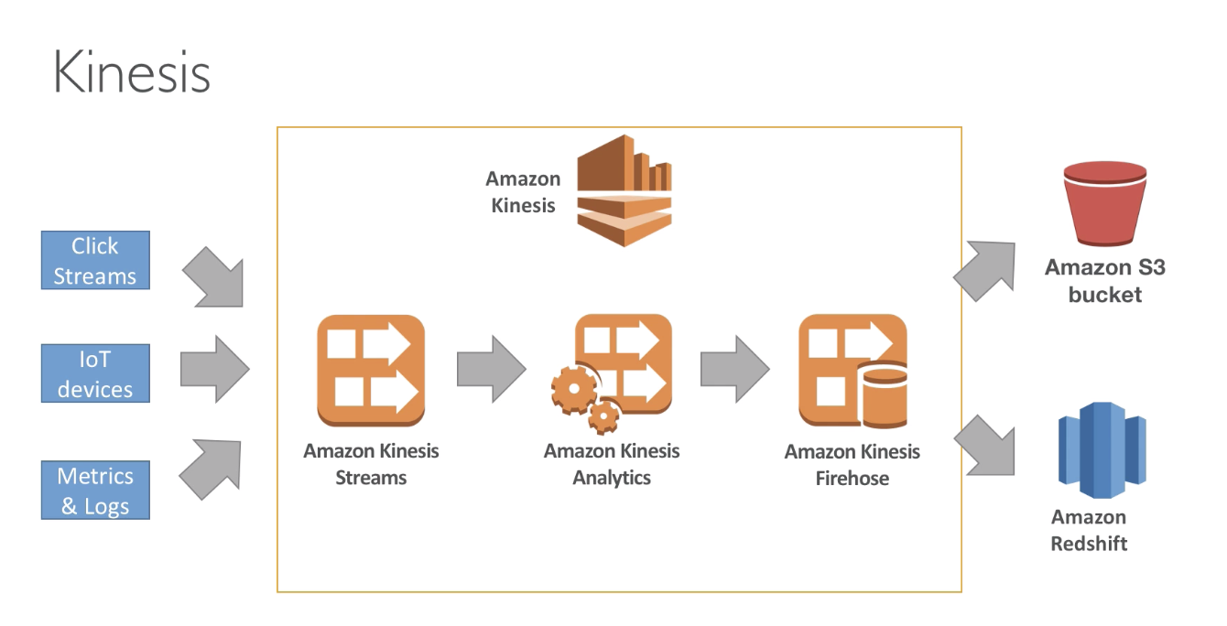

## Kinesis Firehose

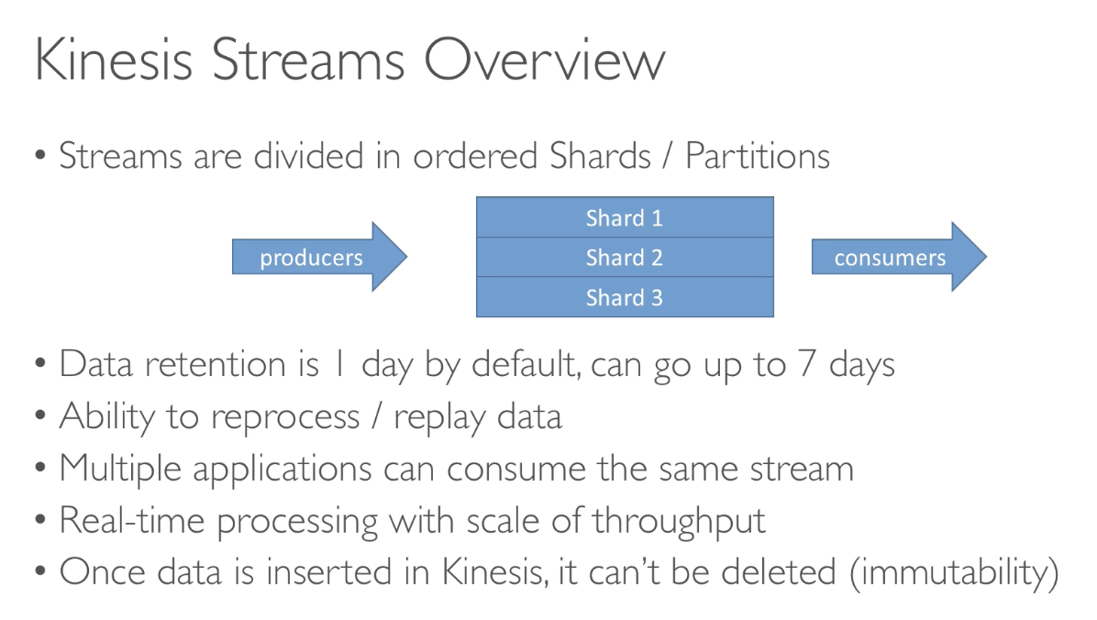

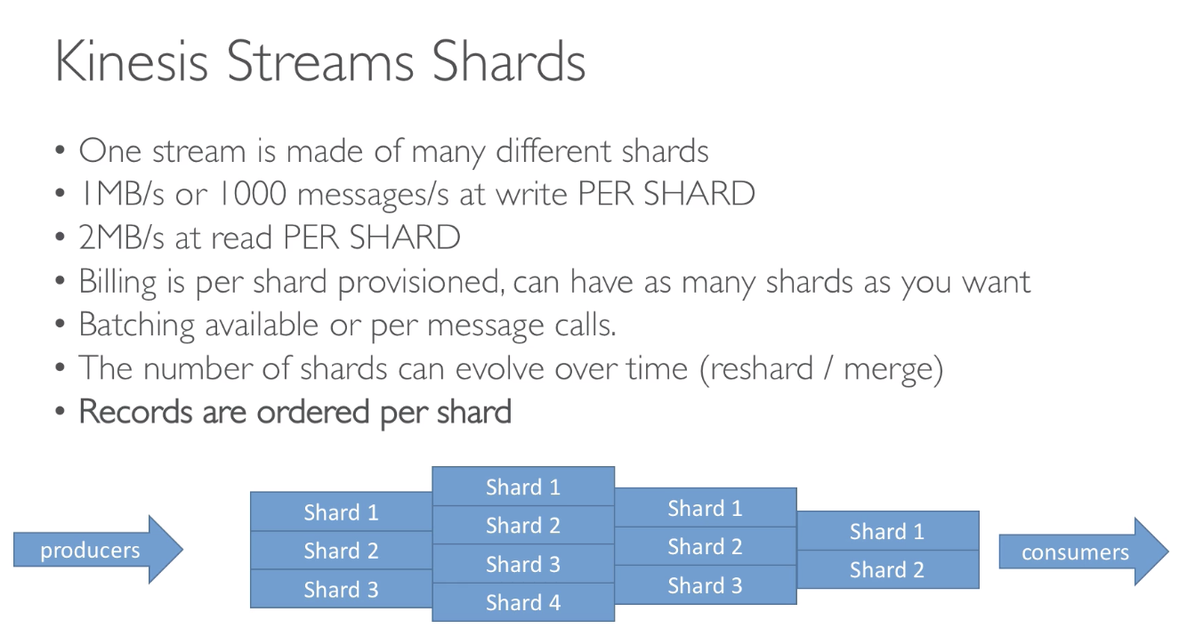

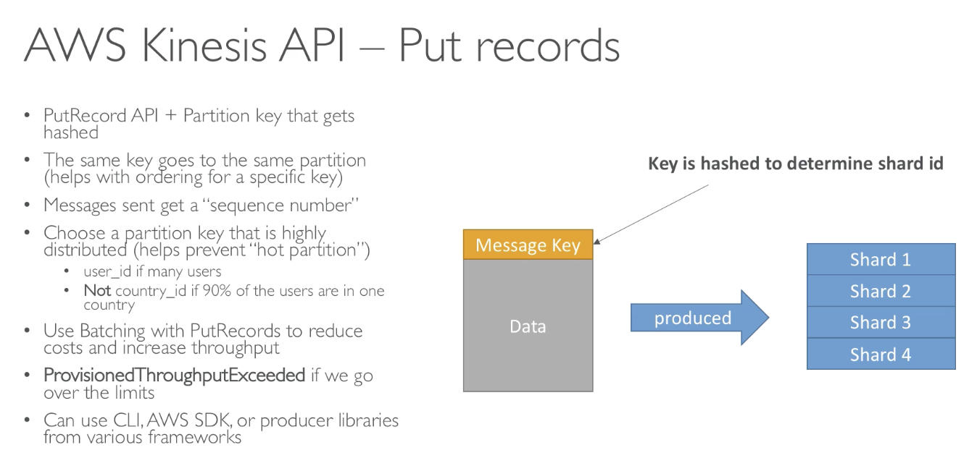

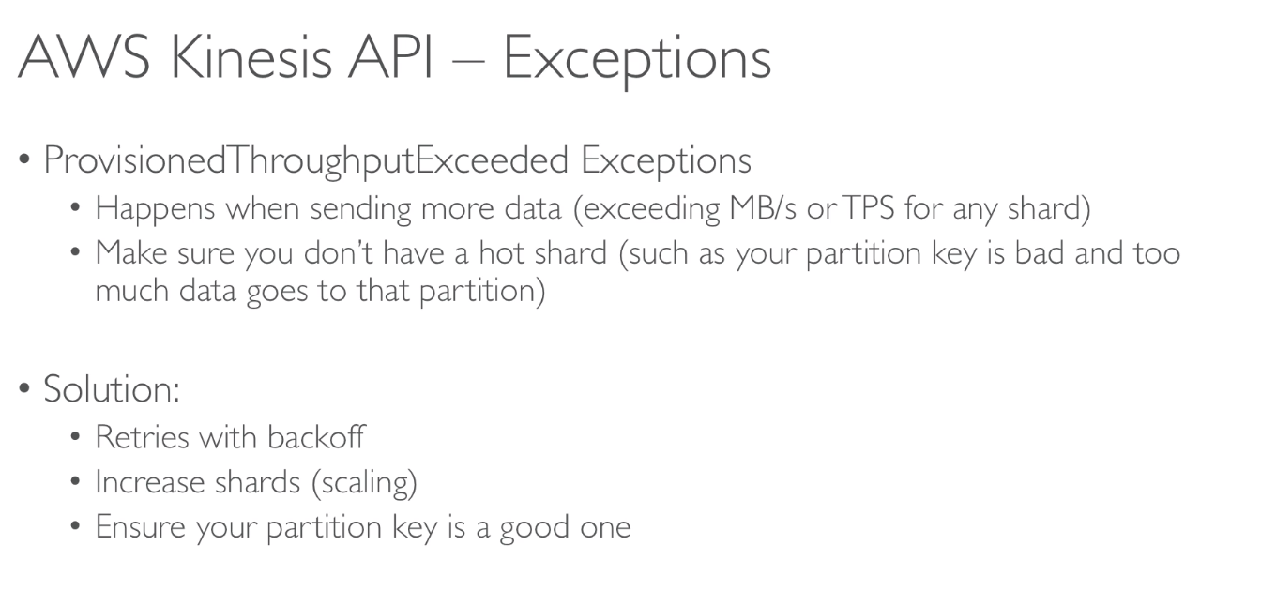

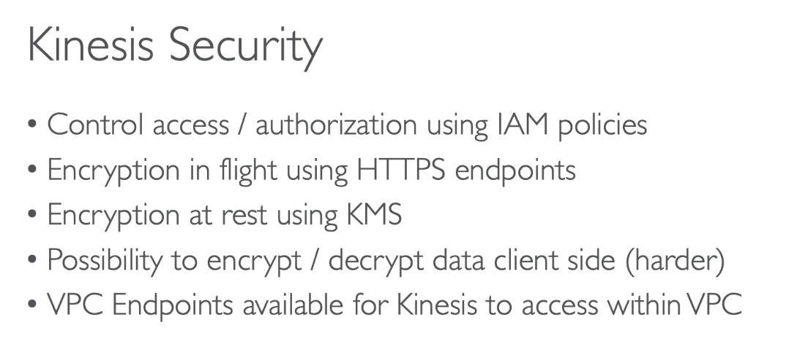

# 168. Kinesis Firehose & Kinesis Data Analytics

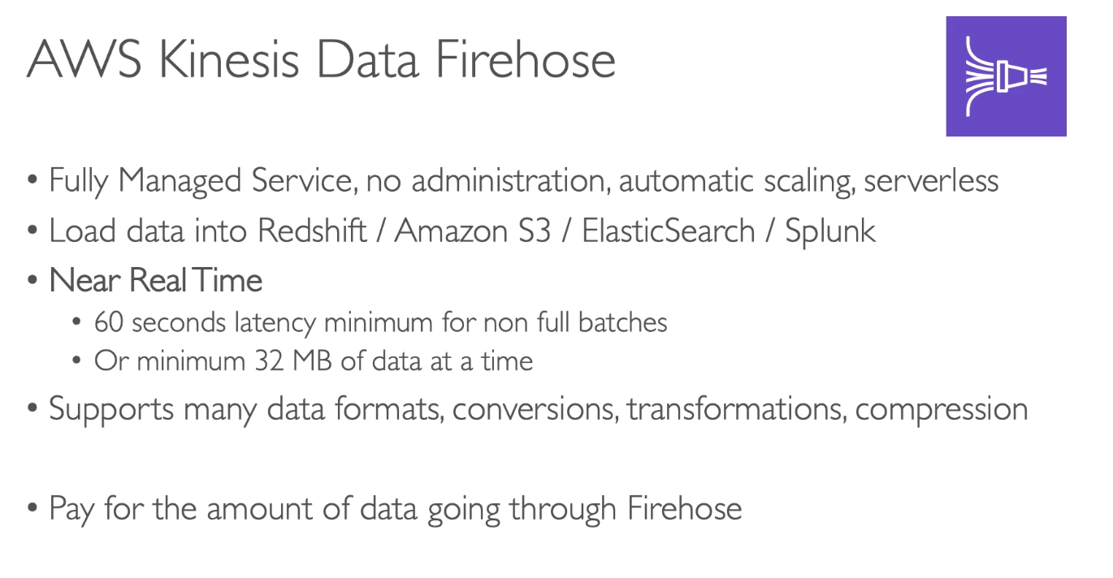

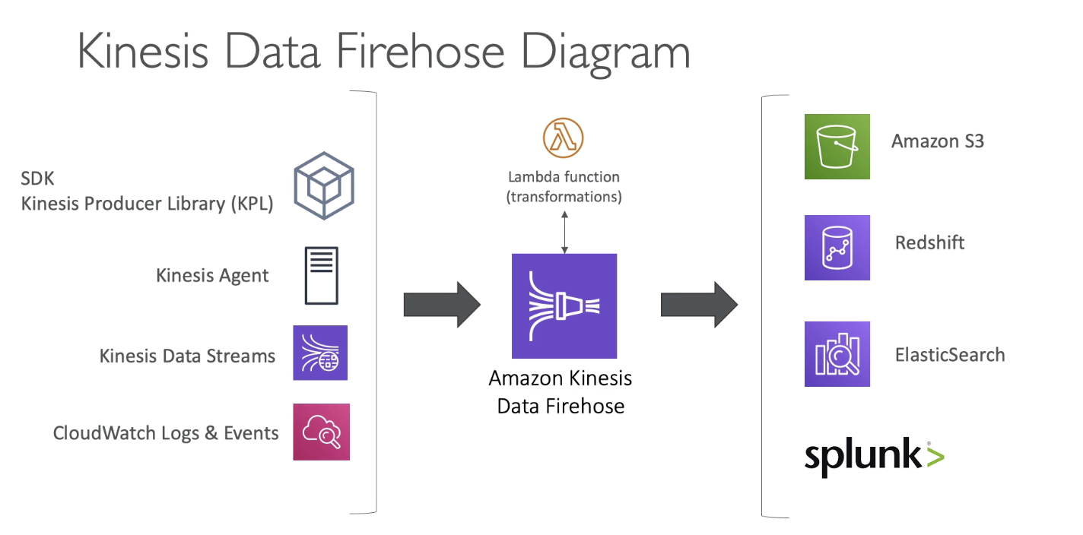

Remember the outputs of Kinesis Firehose

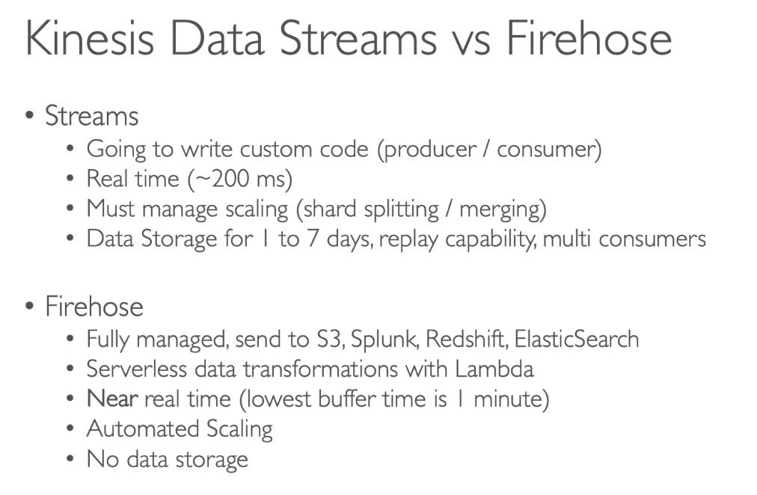

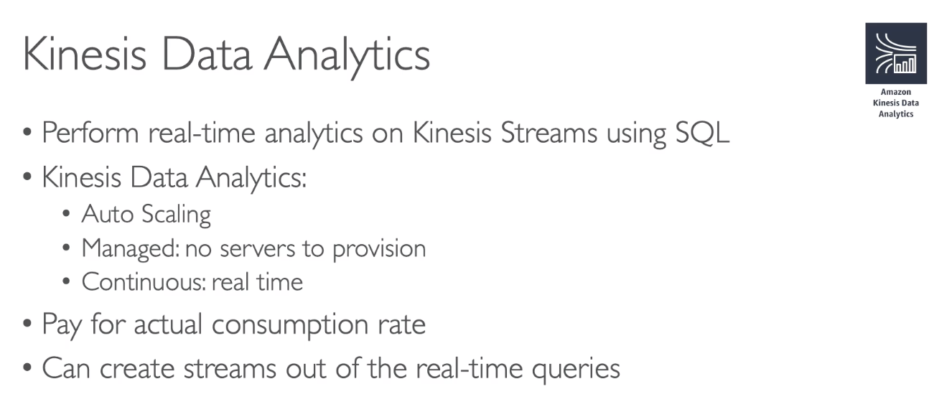

# 169. Data Ordering for Kinesis Vs SQS FIFO

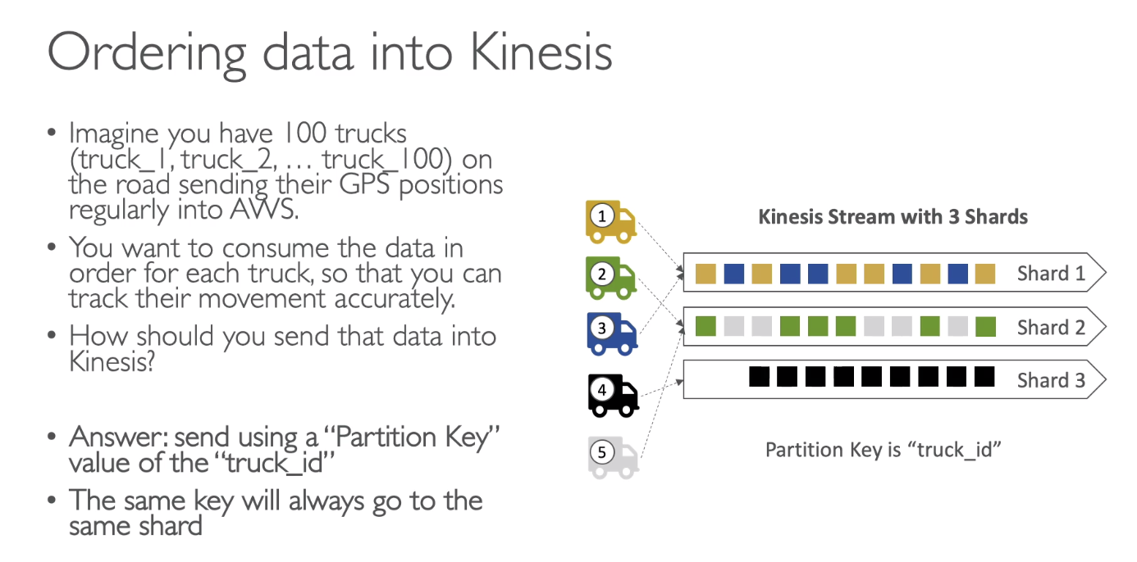

If you have 100 trucks and 5 Shards, each shards on average will have data for 20 trucks. But there is no direct linkage between the truck and shards. Kinesis need to hash the partition key to determine which shard to go to. As soon as we have a stable partition key, each truck will send its data to the same shard and therefore we will have data in order at the shard level.

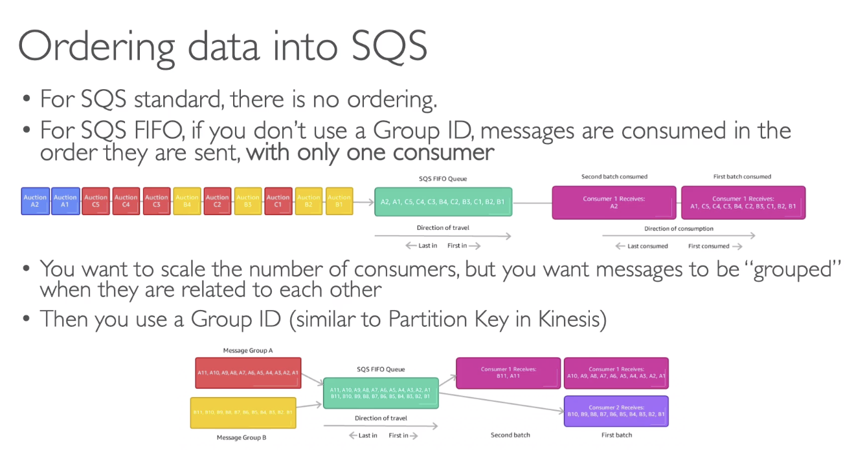

More group we have, more consumer we can have.

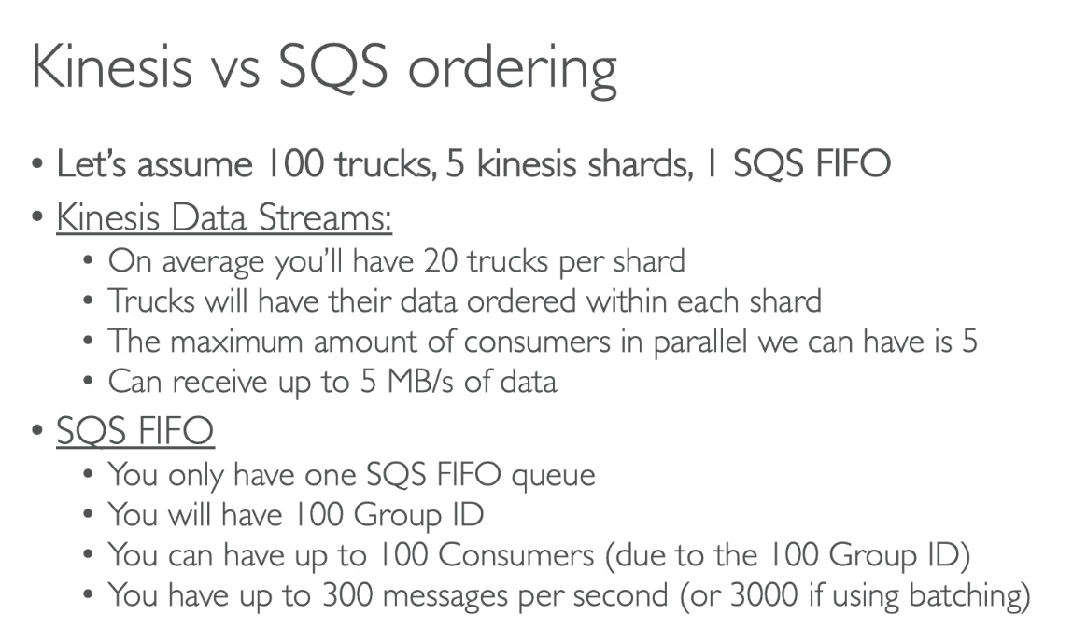

# 170. SQS Vs SNS Vs Kinesis

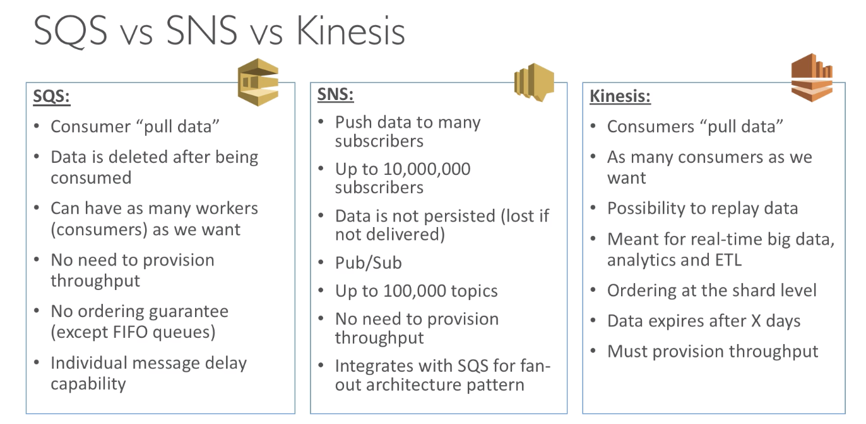

# 171. Amazon MQ

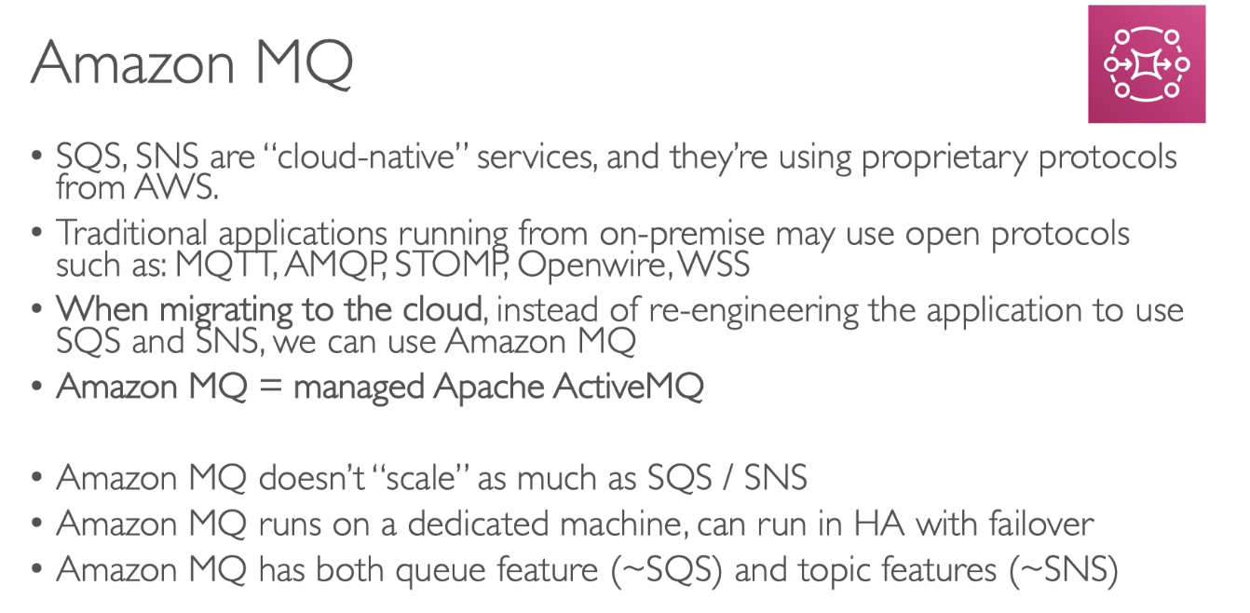

Scenario when we are migrating a app from on-premise to cloud and the app is using MQTT, or the AMQ protocol … what we should use? 🡪 Amazon MQ